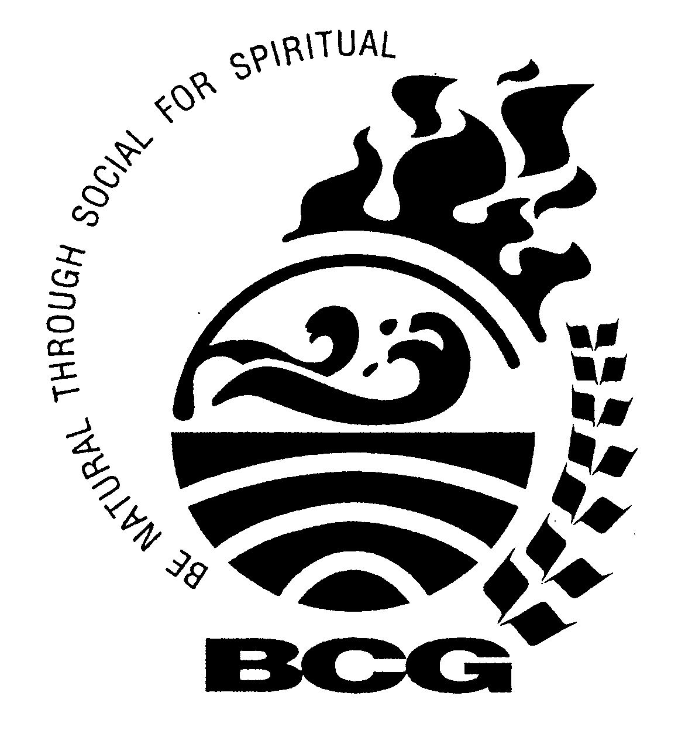
Veer Bhagat Singh Vidyalaya
Malad (West)
2016-2017
Students’ Achievement
SR.  NO. | NAME OF EXAMINATION | ORGANIZED BY | NO. OF REGISTRATION | RESULT
1. | 19th National Science Olympiad of Examination | Science Olympiad Foundation. | V - 17  VI - 05  VII - 21  VIII - 15  IX - 11  X – 05 | Shirke Gauri Vijay (Grade 5) , Shetty Sharanya Sujit (Grade 6), Naik Varad Vinayak (7-B) , Walvekar Madhura Prashant (8-B), Agiwal Shreya sandeep (9-A) stood 1st, received Gold Medal and Certificate.  Shrivastava Parini Prarabdha (Gr.5), Kamath Dhruv Dayanand (7-B), Khan Abha Amar (8-B), Panjari Samartha Satish(9-B) stood 2nd , received silver Medal and Certificate.  Thomas Shaun Shiju (5-B), Raorane Nishchay Santosh(Gr. 7) Patle Avani Tarun (Gr.8), Upadhyay Shruti Sanjay (9-A) Stood 3rd , received Bronze Medal and Certificate.  Shirke Gauri Vijay (Grade 5), Naik Varad Vinayak (7-B), Chirmule Advait Ashutosh (Grade 10) selected for 2nd Level.  Shirke Gauri Vijay (Grade 5), Naik Varad Vinayak (7-B) Received certificate of Merit for 2nd level.  Other participants will be receive the certificates.
2. | Drawing Grade Examination | Directorate of Art Mah. Board | E – 30  I – 20 | In Elementary 27 passed out of 30. (Absent 03)  In Intermediate 18 passed out of 20. (absent 02)
3. | Maharashtra Talent Search Examination | Modern Education Society | VIII-02  IX- 02 | In MTS Exam 2 passed out of 2 students.  Khan Abha Amar (8-B) scored 121 Manjrekar Purvi Prashant (8-B)  Awarded Certificate in appreciation of Meritorious performance in MTS Exam.
4. | Scholarship Examination | Maharashtra State Council of Examination Pune. | V- 24  VIII- 21 | Pre Upper Primary Scholarship Exam (PUP)  Passed -14 Students, Failed –08  Absent – 02 Students.  Students selected for Merit  Bhoite Paridha Vaibhav (Grade 5) – 172 marks. Shirke Gauri Vijay (Grade 5) -232 marks. . Pisal Dhruv Nitin (Grade 5)- 206 marks.Gursahani Shipirist Sunil (Std 5) – 196 Marks. Khan AfifahFatima Mohammed Ali (Std 5) – 204 marks. Narkar Manasvi Mangesh (Std 5) – 212 marks.  * All the students will receive the Result.  * Merit Students will receive the Certificate .  Pre Secondary Scholarship Exam (PSS)  Passed –14 Students, Failed– 04, Absent – 03 Students.  Students selected for Merit  Khan Abha Amar (Std. VIII) – 188 Marks. Manjrekar Purvi Prashant (Std. 8) – 178 marks, Rao Juhika Rajmohan (Std. 8) – 170 marks. Tambe Vandan Vinit (Std. 8) – 168 marks. Walvekar Madhura Prashant (Std. 8) – 218 marks.  * All the students will receive the Result.  * Merit Students will receive the Certificate .
5. | Maths Concept Exam | Brihanmumbai Ganit Adhyapak Mandal | Std. V - 49  Std. VIII - 14 | Std V  - Shaikh Hamza - 94 Marks  (Certificate Grade A)  - Shirke Gauri – 92 Marks.  (Certificate Grade A)  (Elementary Vedic Maths Book Only one student will receive prize who have received Highest Marks)  Std VIII  - Mishra Ekta - 64 Marks (Certificate Grade B)  Only one student received prize (i.e. Book) who have score highest marks (94). Grade A, Grade B & Pass Class Students received Certificate of Passing.
6. | Homi Bhabha Balvaidnyanik Competition | The Mumbai Science Teachers’ Association | Std. VI – 14  Std. IX - 06 | Std VI - Eligible for Passing Certificate –12  Std IX - Eligible for Passing Certificate - 02  Selected for Practical – 0
7. | Hindi Public Exam | Mumbai Prantiya Rashtrabhasha Pracharsabha | Level I (V-VII) – 19 students  Level II (VI-VII) – 11 students  Level III (VII) –  03 Sudents  Level IV (VIII)  06 Students | Level I –  Distinction – 10, Ist Class – 09  Level II –  Distinction – 01, I st Class – 05, IInd Class -02, Passed Class- 01  Level III-  I st Class – 03  Level –IV  I st Class – 01,  IInd Class - 01, Passed Class – 02  Students secure Distinction  LEVEL -1  DEV TUSHAR TASKAR (5-A) 80mks,  KAVISH NITESH KOTHARI (5-A) 83mks, AKANKSHA MINESH CHODANKAR (5-A) 76mks, ZAINAB FARRUKH SHAIKH (5-A) 78 mks, SHWETA GIRISHA SHARMA (5-B) 78 mks, HIYA KANESH MEHTA (5-B) 82 mks, ARWA HUZAIFA SHABBIR VASAIWALA (5-B) 84 mks, GAURI VIJAY SHIRKE (Grade 5) 79 mks, AARYAN YUNUS KHAN (6-A) 83 mks, SURBHI SURENDRA CHANDOLKAR (Grade 7) 81 mks,  LEVEL 2  SIDDHARTH JAIPAL SING (7-A) 75 mks,
8. | Marathi (Pravina ) Examination | Brihan Mumbai Nimistar Marathi Shikhak Sanghatna | V-24  VI-13  VII-17  VIII-17  IX-07  X-37 | Students who stood 1st are-  NARKAR MANASVI MANGESH (V)Scored 99 mks. KHAN AARYAN YUNUS (VI) Scored 86 mks. WALAVALKAR DHRUV RAMCHANDRA (VII) Scored 93 mks. WALVEKAR MADHURA PRASHANT (VIII) Scored 96 mks. MARCHANDE SAKSHI SATISH (IX) Scored 65 mks. JOSHI ADITI PRAVIN (X) Scored 71 mks.  Students who stood 2nd are-  RAIBHANDARE DIYA DINESH (V) Scored 97 mks.  DALVI TRISHA MILIND (VI) Scored 82 mks.  SAKPAL AAYUSHI SANJAY (VII) Scored 88 mks. LAKADE SIDDHI RAJENDRA (VIII) Scored 95 mks.  SHARMA SWATI GIRISH (IX) Scored 60 mks. SURVE DEV SANJAY (X) , SAHU SAKSHI RAJKUMAR (X) Scored 69 mks.  Students who stood 3rd are  SHIRKE GAURI VIJAY , DORUGADE PARTH VISHNU, ZAINAB FARRUKH SHAIKH, CHODANKAR MINESH AKANKASHA, VAISAIWALA ARWA HUZAIFA (V) Scored 96 mks. REDKAR MAYURI NITIN (VI) Scored 78 mks. NAIK VARAD VINAYAK (VII) Scored 81 mks. MAJREKAR PURVI PRASHANT (VIII) Scored 92 mks. BISHT SAKSHI MAHINDAR (IX) Scored 56 mks. MHATRE SHRUTI RAMESH (X) Scored 68 mks.  Distinction –60students  Class V - 21 students  Class VI- 06 students  Class VII- 08 students  Class VIII – 07 student  Class IX – 02 students  Class X – 16 students  Certificates were awarded to all passed participant.
9. | Ganit Pravinya Exam | Mumbai Ganit Adhyapak Mandal | Std. V – 10  Std. VIII - 03 | No one passed the exam.
10. | 13th International Informatics Olympiad Examination | Silver Zone Foundation, New Delhi | V – 05  VI – 03  VII – 10  VIII – 03  IX – 05  X - 03 | 100 % results  Students who stood 1st ,  Shirke Gauri Vijay (Grade 5), Gurav Spandan Prasad (Grade 6), Kamath Dhruv Dayanand (7-B), Khan Abha Amar (8-B), Malankar Tushar Eknath (Grade 9), Chirmule Advait Ashutosh (Grade10) received gold medal + Certificate of Achievement.  Students who stood 2nd,  Shrivastava Parini Prarabdha (Grade 5), Walavalkar Dhruv Ramchandra (7-B), Tandale Aayushi Swadhin (VIII), Rao Venoy Narayan (Grade 9) Mathai Sarah Samuel (Grade 10)  received silver medal + Certificate of Achievement.  Students who stood 3rd,  Pisal Dhruv Nitin (Grade 5), Naik Varad Vinayak (7-B),  received Bronze medal + Certificate of Achievement.  Shirke Gauri Vijay (Grade 5), Kamath Dhruv Dayanand (7-B), Khan Abha Amar (8-B)  selected for 2nd level & Receive certificate of Special Achievement.  All other students received certificate.
11. | Graphic Championship | Computer literacy foundation |  | NOT CONDUCT
12. | 10th International Olympiad of Mathematics Examination | Science Olympiad Foundation. | V – 21  VI – 18  VII – 24  VIII –14  IX – 07  X - 05 | Pisal Dhruv Nitin (Grade 5) , Pardesi Jaiswal Nikhil Nitin (Grade 6), Kamath Dhruv Dayanand (7-B), Siddique Mohd Mudasser Kazi Naeem (8-A), Srivastava Ahsaas Vimal (Grade 9) stood 1st, receive Gold Medal and Certificate.  Shirke Gauri Vijay (Grade 5), Gurav Spandan Prasad (Grade 6), Naik Varad Vinayak (7-B), Khan Abha Amar (8-B) stood 2nd , receive silver Medal and Certificate.  Narkar Manasvi Mangesh (5-B), Kapadia Kartik Paresh (6-A), Patodia Manan Dilip (7-B), Pal Gaurav Ashok Kumar (8-B) Stood 3rd , receive Bronze Medal and Certificate.  Pisal Dhruv Nitin (Grade 5), Pardesi Jaiswal Nikhil Nitin (Grade 6), Kamath  Dhruv Dayanand (7-B), ) selected for 2nd Level & received Certificate of Merit.  Other participants will be receive the certificates.  Pisal Dhruv Nitin
13. | 7th International English Olympiad | Science Olympiad Foundation. | V – 21  VI – 14  VII – 17  VIII –12  IX – 11  X - 03 | Thomas Shaun Shiju (5-B), Gurav Spandan Prasad (Grade 6), Kamath Dhruv Dayanand (7-B), Khan Abha Amar (8-B), Acharya Shashank Charudutt (std.9 -B) stood 1st, receive Gold Medal and Certificate.  Shirke Gauri Vijay (Grade 5), Khan Aaryan Yunus (6-A), Shukla Piyusha Yogendra (Grade 7), Acharya Bhavi Ketan(8-A), Malankar Tushar Eknath ( Grade 9) stood 2nd , receive silver Medal and Certificate.  Narkar Manasvi Mangesh (5-B), Shivalkar Tanaya Swagat (6-A), Sakpal Aayushi Sanjay (7-A), Ingole Arnav Nilesh (Grade 8), Agiwal Shreya Sandeep(9-A), S Stood 3rd , receive Bronze Medal and Certificate.  *There is no Level – II Exam for International English Olympiad (IEO).
14 | 7th Geography Olympiad Examination | IBGB Learning Society | JR.CATEGORY  V – 08  VI – 03  VII – 09  SR. CATEGORY  VIII – 05  IX – 06  X - 04 | Medal Winners for Junior Category are :  Walavalkar Dhruv Ramchandra (VII) Gold Medal + Merit Certificate  Kamath Dhruv Dayanand (VII)  Silver Medal + Certificate  No one win the Medal from Senior Category.  Shrey Vilas Koli (7-A), Varad Vinayak Naik (7-B), Mohd. Sibtain Raza Shaikh (8-B), Ahsaas Vimal Srivastava (Gr.9) reveived Certificate of Merit.  All other students received Participation certificate.  Walavalkar Dhruv Ramchandra (VII) Received National Finalist Trophy & Participation certificate at 2nd level.

